LAB EXPERIMENTS OUTPUTS
CODE-
num <- c(10, 20, 30, 40)
print(num)
print(typeof(num))
char <- c("Apple", "Mango", "Orange")
print(char)
print(typeof(char))
log <- c(TRUE, FALSE, TRUE)
print(log)
print(typeof(log))
EXP-01
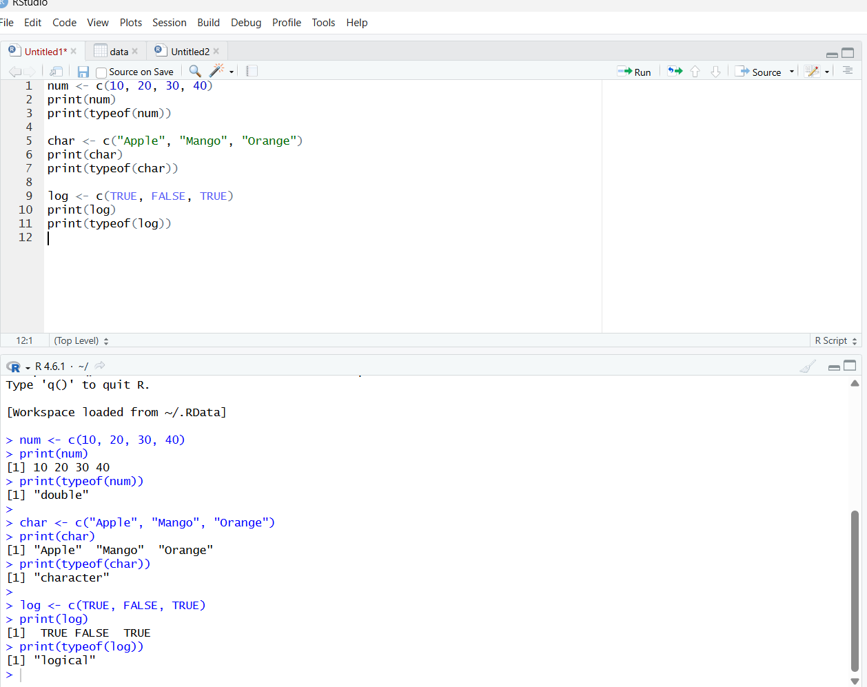

EXP-02
CODE
A <- matrix(1:20, nrow=5, ncol=4, byrow=TRUE)
rownames(A) <- paste0("R", 1:5)
colnames(A) <- paste0("C", 1:4)
print(A)
B <- matrix(1:9, nrow=3, ncol=3, byrow=FALSE)
rownames(B) <- paste0("R", 1:3)
colnames(B) <- paste0("C", 1:3)
print(B)
C <- matrix(1:4, nrow=2, ncol=2, byrow=TRUE)
rownames(C) <- paste0("R", 1:2)
colnames(C) <- paste0("C", 1:2)
print(C)
OUTPUT-
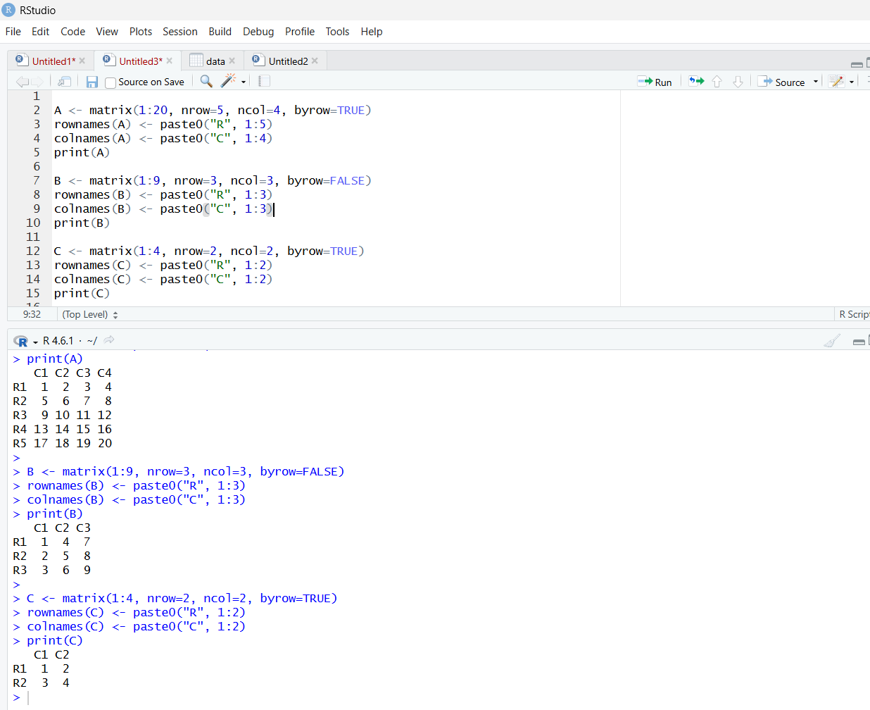
EXP-03
CODE
a <- 1:24
b <- array(a, dim = c(2, 3, 4))
print(b)

OUTPUT-
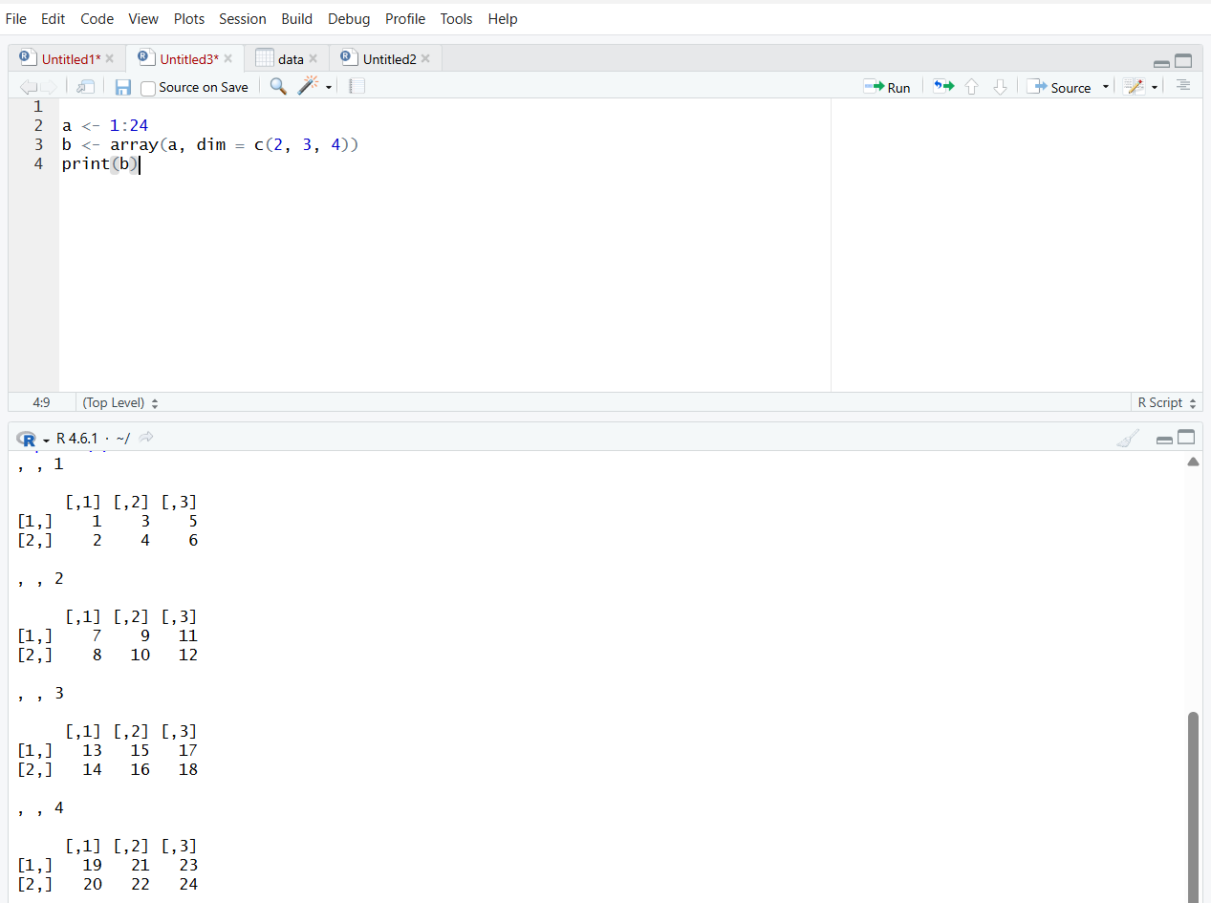

EXP-04
CODE
a <- 1:8
b <- array(a, dim = c(2, 2, 2),
dimnames = list(c("R1", "R2"),
c("C1", "C2"), c("T1", "T2")))
print(b)
print(b[2, 1, 2])
OUTPUT
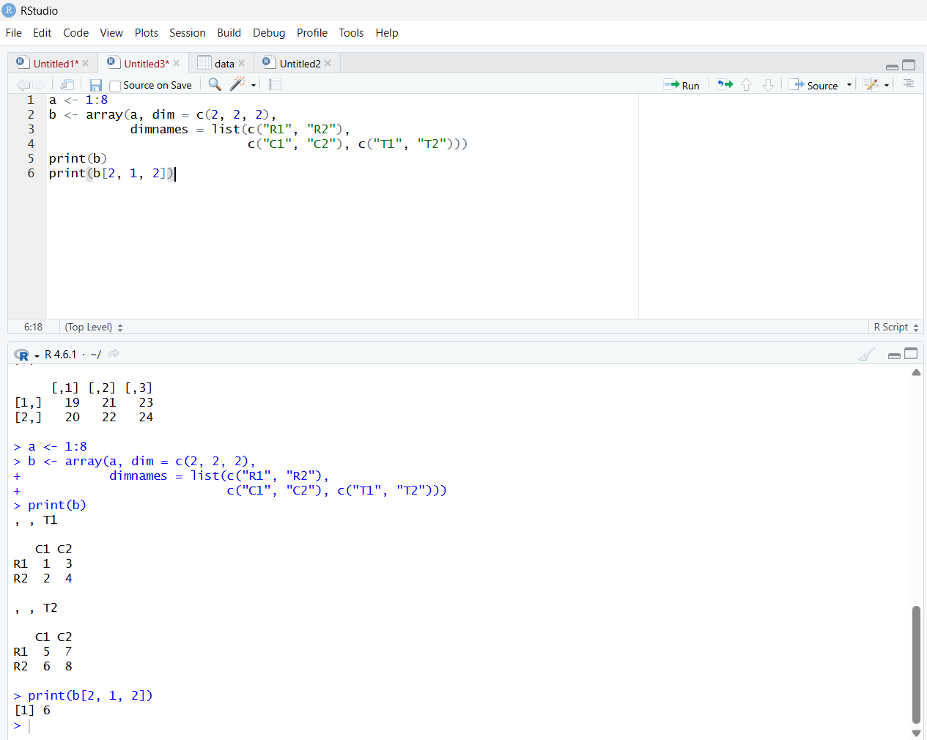

EXP-05
CODE-
a <- c("Short", "Medium", "Tall", "Medium", "Tall", "Short")
b <- factor(a)
print(b)

set.seed(10)
c <- sample(LETTERS[1:5], 8, replace = TRUE)
d <- factor(c)
print(d)
OUTPUT-
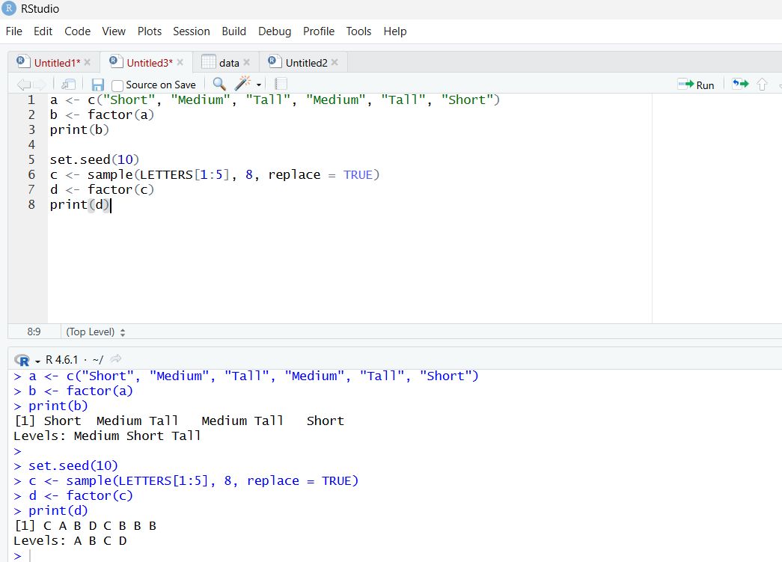

EXP-06
CODE
a <- c(1, 2, 3, 4)
b <- matrix(1:6, nrow = 2, ncol = 3)
c <- function(x) x^2
mylist <- list(Vector = a, Matrix = b, Function = c)
print(mylist)
OUTPUT
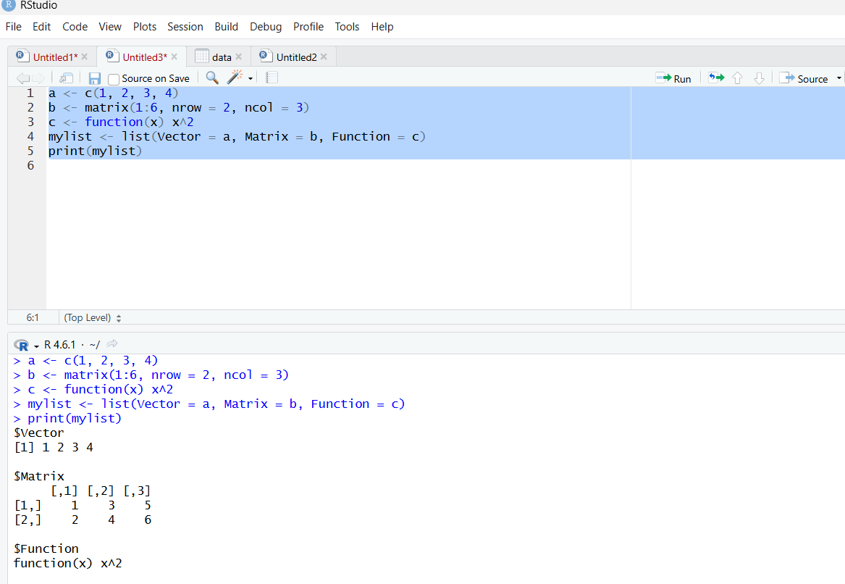
EXP-07
CODE
n <- 12
factors <- integer(0)

for (i in 1:n) {
if (n %% i == 0) {
factors <- c(factors, i) }
}
print(factors)
set.seed(123)
print(sample(-50:50, 10, replace = TRUE))
for (i in 1:100) {
if (i %% 15 == 0) {
print("FizzBuzz")
} else if (i %% 3 == 0) {
print("Fizz")
} else if (i %% 5 == 0) {
print("Buzz")
} else {
print(i)
}
}
OUTPUT
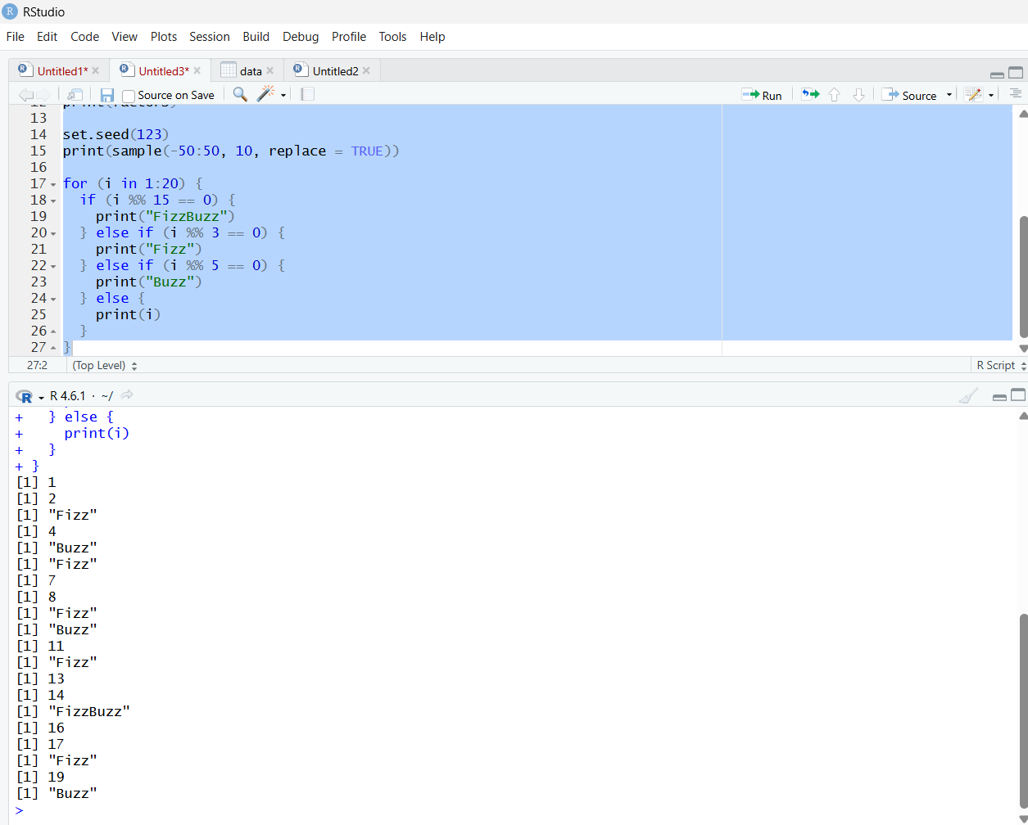
EXP-08
CODE
set.seed(123)
x <- rnorm(100)
y <- table(round(x))
print(as.data.frame(y))
OUTPUT
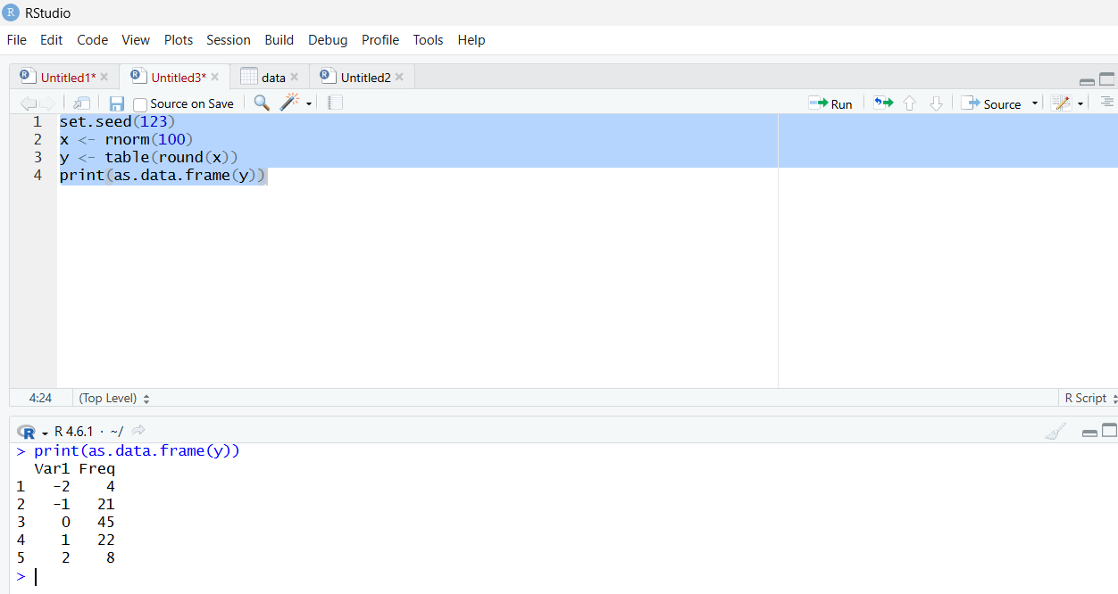

EXP-09
CODE
plot(1, type = "n",
xlim = c(0, 10),
ylim = c(0, 100),
xlab = "X axis",
ylab = "Y axis")
OUTPUT
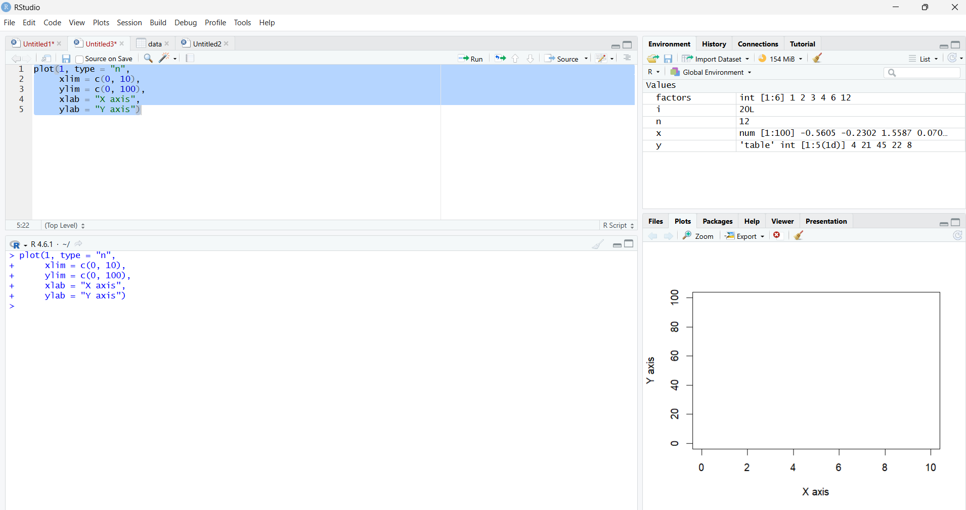

EXP-10
CODE
x <- data.frame(
name = c("Anu", "Bala", "Charan", "Divya", "Esha"),
score = c(85, 62, 90, 75, 88),
attempts = c(1, 3, 2, 2, 1),
qualify = c("yes", "no", "yes", "no", "yes")
)
print(x)
print(x[1, ])
print(x[, "score"])

x <- rbind(x, data.frame(
name = "Farhan",
score = 70,
attempts = 3,
qualify = "no"
))
x$grade <- c("A", "C", "A+", "B", "A", "B")
x <- x[order(-x$score), ]
print(x)
write.csv(x, "x.csv", row.names = FALSE)
OUTPUT
